
Travelution

Business Plan

Table of Contents

Company Description, Mission Statement, Value Proposition ………………………………… 1
Vision Statement, Values, Industry Analysis ………………………………………………….. 2
Market Analysis ………………………………………………………………………………... 4
Competitive Analysis …………………………………………………………………………... 8
Strategic Positioning ………………………………………………………………………….. 10
Marketing Strategy ……………………………………………………………………………. 14
Management and Organization ……………………………………………………………….. 17
Start-Up Costs & Use of Funds ………………………………………………………………. 21
Growth and Exit Plan ………………………………………………………………………..... 22
Timeline ……………………………………………………………………………………..... 25
Financial Appendix …………………………………………………………………………… 26
Appendix ……………………………………………………………………………………… 29

Executive Summary
Travelution CEO, Ava Sowell, has spent her life traveling the world. In 2017, she decided to take a vacation to Austria and spent upwards of twenty hours planning her itinerary to make sure the trip would be worthwhile. Once she arrived in Innsbruck, one of Austria’s major cities, she met up with some friends who lived in the area. She soon realized that spending time with locals gave her an experience unlike any she could plan from her living room.
When Ava returned to the US, she started thinking about how much more authentic her experience was with the help of her native friends, and how she could share that experience with the world. This thought was the basis for Travelution, and through the help of her founding team this idea is quickly becoming a reality.
Travelution is a web based platform that aims to connect college students across both domestic and international borders in an attempt to provide the most authentic travel experience available. Any college student with a university sponsored email address is given access to log into the platform, create a profile of their travel preferences, search the destination they wish to travel to, and are prompted with a list of local ambassadors that match their profile. These locals are able to provide either a custom itinerary with the area’s best local restaurants, activities, and events, or even take the travelers on a physical tour of the destination that showcases the city's highlights. Once the user and ambassador have been matched, the user will be prompted to provide payment through our platform, and will be able to access a communication stream with their ambassador until the itinerary or tour has been completed.

Company Description
Travelution, LLC is an online travel company based in Tampa, FL that will connect students with local university students (ambassadors) in the city that they are traveling to. The traveler can then hire the ambassador to set up a college campus tour with a surrounding city itinerary, or provide a guided tour for a more personable experience. In addition to tours and itineraries of overall cities, we also offer blogs and an interactive chatbot for other information for different top travel destinations.
Mission Statement
Travelution aims to connect university students from around the world in order to make traveling a more personal and meaningful experience. Our team came together and asked the question, how can we provide people with authenticity on their trips and allow travelers to know a local wherever they go?
Value Proposition
Our customers will be Millennials and Generation Z people that mostly range from seniors in high school to seniors in college. Seniors in high school can use our platform to connect with ambassadors at a university that the high school senior is considering to attend. This will give the high school senior information that the university may not provide in terms of things to do around the city or what it is really like to attend the university. A tour with an ambassador in this situation can also be valuable because most university tours are trying to sell you on the school instead of giving you the real insight of the school and the city.
For the university student customers, they will be able to benefit most from when they are planning to study abroad or just traveling on their own time exploring the world. A lot of university students want to study abroad with the goal of experiencing a different country and culture. Travelution will offer university student ambassadors in locations where studying abroad is popular so that the traveling students can connect with them and see what it is like to not just be a student in that country, but to know the area’s most popular activities and attractions. This process is the same and very valuable for students who are just traveling abroad but aren’t attending a study abroad program. When traveling abroad alone or not knowing much about a foreign country, being able to connect with a local who you can trust is something that is very valuable.
As a person in the range from seniors in high school to seniors in college, this is the prime time to travel and see the world. This is the time where one is trying to figure out who they are as a person and what they want to do with their lives. According to Expedia Media Solutions Millennials and Generation Z people have more travel days per year than Generation X and Baby Boomers. (see Appendix).

Vision Statement
Travelution aspires to become a globally recognized brand with an extensive network of local ambassadors around the world and provide authentic, local experiences to all travelers.
Values
As a group of world travelers ourselves, our team places extremely high value on promoting creativity, peace, spontaneity, and the embracement of cultures other than our own. These core values will be the cornerstones of our company culture and brand and will be used as a roadmap for the future direction of Travelution.
Industry Analysis
With regards to our business model and the demographic we aim to serve, Travelution falls under both the tour operator and travel agency industries. Companies in both industries arrange tour packages and assist travelers in planning their vacation, business trip, or family reunion. These industries are service sectors and fall under NAICS codes 56152 (Tour Operators in the US) and 56151 (Travel Agencies in the US). The steady increase in disposable income among consumers has benefited both of these industries as more people are spending money on travel. Per capita disposable income is projected to increase in 2019, presenting more opportunities for the industry as a whole (“US Disposable Personal Income Per Capita”). Tour operators and travel agencies strive to increase the number of inbound trips by non-residents, however domestic trips make up a large part of their revenue. Domestic trips taken by US residents are projected to rise, growing an annualized 1.6% over five years to 2024 (“Industry Market Research, Reports, and Statistics”). Both industries show great potential and obtain components of what Travelution envisions to become in the long run.
According to IBIS World, over the past five years the Tour Operators industry has shown steady growth. In 2019, the revenue of the tour operators’ industry is estimated at $7.8 billion, with profits totaling to $535.3 million. As a result, disposable income in the industry has risen significantly. The industry as a whole has an annual growth rate of 2.4%; this rate has been projected to be relatively stable between 2019 and 2024. The industry’s average labor cost is calculated to be $45,608 per year. A tour company would hire three to four employees minimum considering the industry average. Therefore, the company is expected to spend $182,432 per year on employee salaries.
The industry has a wide product and service range, including international packaged tours, operating travel tours, reselling tours. Tourism-related industries are highly dependent on favorable economic conditions. In the last five years the global economy has significantly strengthened, providing more opportunity for businesses in this sector. Despite this benefit, tourism as a whole is very vulnerable to wars, political instability, and viral outbreaks. The geopolitical environment plays a large factor in the success or failure of this industry due to the fear inflicted in potential consumers. Technological changes have hit the industry hard since some customers are starting to use websites and mobile applications to reduce their travel expenditure, as well as plan their vacations. This is a setback for companies who have failed to adapt and remain solely brick and mortar.
The tour operator’s industry is in the mature phase of its industry life cycle. It has more defined market segments and services. Also, the industry value added is projected to increase from 2014 to 2024, which is common among mature industries. This means the industry contribution is annualization rate is expected to grow by 2.8% (IVA). The US GDP is anticipated to rise by 2% during the same period. The industry is also expected to have higher competition due to the emerging new e-businesses competitors.
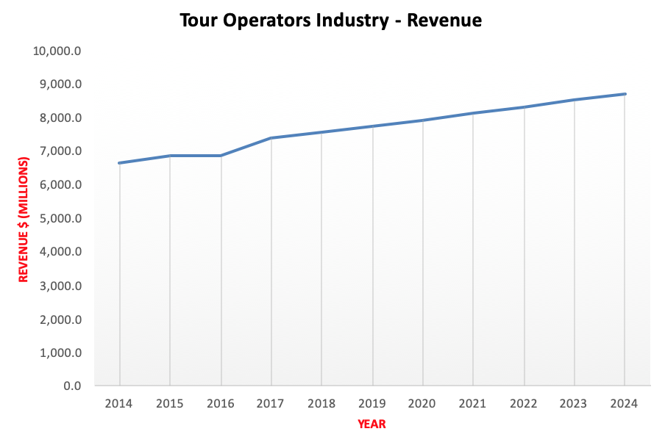
There is a growing interest in premium packages and services that cannot be overlooked. Customers are looking for offerings that specifically meet their needs. The industry encompasses a supply and distribution chain with small companies offering customizable tour packages. Some of these include outdoor tours, food tours, tours for singles, and other specific services. These companies have accrued a total revenue of $7,757.6 million in 2019.
Rising disposable income is contributing to the increase in both domestic and international tourism. This has created more demand for online and mobile applications such as “Trip It” which people can be simply accessed through a cell phone. There is a significant shift in the industry resulting from these technological changes and trends. Companies are adapting to a digital platform to obtain larger market share, and the ones who haven’t pivoted are beginning to see the negative effects. Applications can help tourists manage their hotels, flights, restaurant deals and excursions all from their pocket.
In addition to this significant change, consumers are also becoming more interested in “green” findings which can be found on TripAdvisor relating to environmental friendliness. The tourism industry as a whole is becoming increasingly segmented giving consumers the option to find business offering very specific services to meet their needs. This has given rise to more niche companies, such as catering to business travel for example, which are obtaining large market share.
Given the popularity and success of these niche companies in our industry, we feel extremely confident that the strategic position our company has taken will allow us to be more successful in creating a strong brand identity that resonates with our target market as well as delivering a high quality service specifically tailored to this group.
Market Analysis
Travelution Market / Market Segments

The travel industry as a whole is enormous with many different segments. Marketing our services to all travelers would be ineffective as a startup, because we would not be catering to the individual needs of our clients. Our goal is to strategically choose a niche market so we can personalize our services and gradually acquire a larger market share.

We are living in an era where people (Millennials and Generation Z) are prioritizing world exploration and adventure throughout their youth, rather than waiting until retirement. Not only are people traveling more, but they are looking for more unique and authentic experiences rather than solely visiting “tourist traps.” Airbnb is taking advantage of this with their “Live There” campaign, encouraging people to live like a local when they visit a new city to get a true experience (Mildenhall, 2017).

Travelution contains two different user bases. We must market to both travelers seeking authentic experiences as well as to locals who are knowledgeable about their city and willing to share that information with others. That being said, connecting college students around the globe would be a great starting point. In 2018 out of nearly 20 million college students about 8.4 million (42.15%) are between the ages of 18-21 years old (McCubbin, 2018). This is almost the exact range for Generation Z and Millennials, meaning that this is a great place for us to start with marketing. Colleges and universities sponsor study abroad programs and internship opportunities across the globe. In addition, more and more students are enjoying backpacking during their summer vacation as a practical and inexpensive way to explore.

As far as marketing for local ambassadors to represent their city, we have concluded that college students would also be a great selection for this position. Social media has created an era of influencers and micro-influencers across millennials and Generation Z. These individuals are eager to share information in hopes that people will find it useful and “follow” them for more content (Dinesh, 2017). We will utilize this trend to recruit college ambassadors to show off their city while getting paid for it. They will provide tours, itineraries, and general communication for travelers coming to their city. This will help them build their social media platforms by acting as a representative of Travelution, while getting to meet people from around the world.

Further Segmentation

For the college demographic this could be directed towards seniors getting ready to accept a job offer or attend graduate school in a place they’re unfamiliar with. Travelution could help people get acclimated to a new city and make a group of friends after a short time of being there. Starting a graduate program or a new job in an unfamiliar place can be overwhelming by itself. We will help take the stress off of getting used to a new place, according to Reader’s Digest.

Demographic/Geographic/Psychographic Data:

Demographic - Gender, Age, Employment

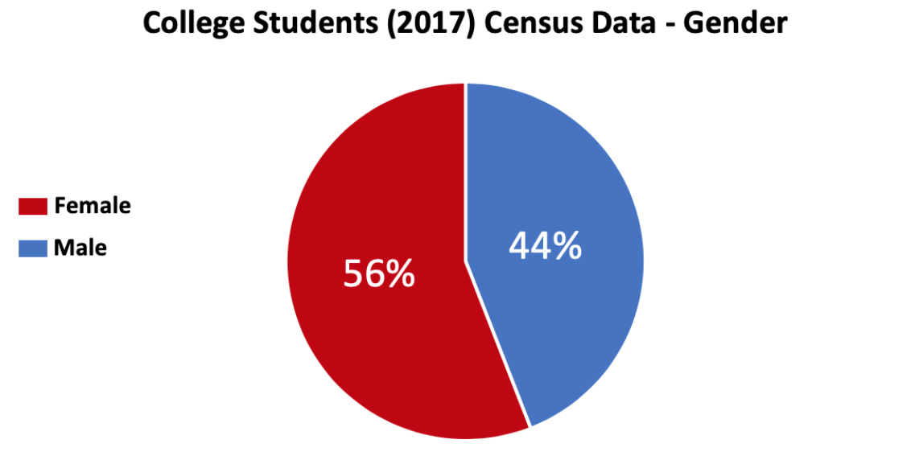

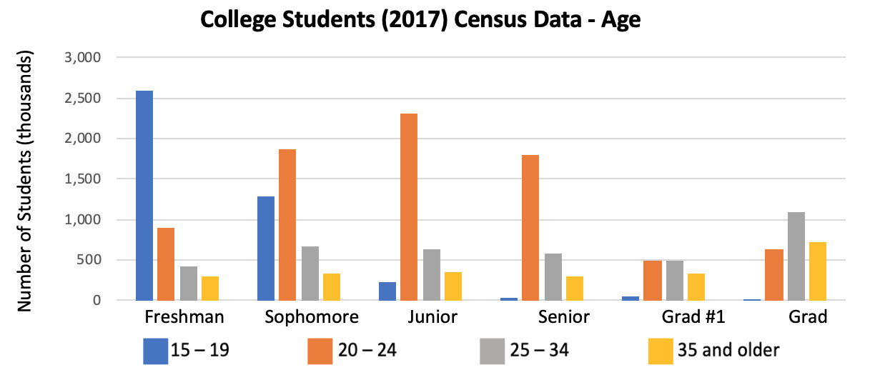

In 2018 college students in the United States alone spent a total of $514 billion with $212 billion being discretionary spending (Ercule, 2019).
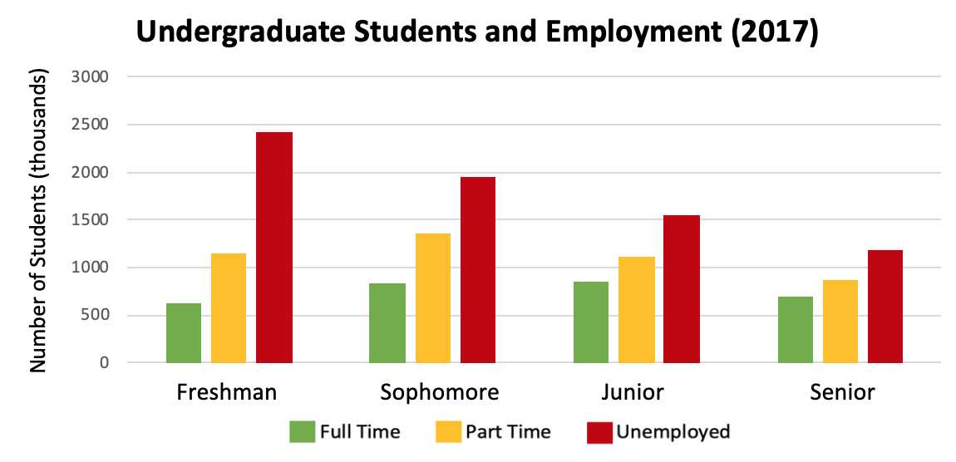
Geographic

Colleges and universities are dispersed around the globe, leaving endless opportunities for expansion. We will initially focus our efforts in Tampa, FL where our company is based. Once we have established a base and reputation we will expand into Boca Raton and Miami, both popular destinations. Before branching out to different cities we will conduct extensive market research to ensure that the location will be profitable. Tourism is booming in Florida and the state hosts a large amount of study abroad students, so we will utilize the opportunity here before expanding to different states and countries.

Psychographic

College students share multiple psychographic traits that will be catered to by our services. Having fun and finding connections are highly valued. The majority want to make friends, have unique and memorable experiences, and become connected with their surroundings. These emerging generations value authentic and sincere advice when it comes to travel, and other aspects of their lives. Through social networking with local students, our target market will fulfill their desire for legitimate advice on how to maximize that specific location to meet their needs. Regarding an article on college students “social connectedness is considered a significant predictor of adjustment. In general, experiencing positive social interaction can encourage psychological well-being and adjustment” (Rivas and others, 2018).

Trends

Tourism in the United States is consistently impacted by global trends. Technology has facilitated the constant creation and growth of businesses in the travel industry. We are in a digital age where many successful companies have switched over to online and application-based platforms. This has helped them reach a wider range of users, and easily distribute influential marketing content. Conversations have been facilitated, connecting people from all over the world and informing travelers on different tours and other means of exploration that are out there. Data collection has helped companies in the industry to get a better understanding of what travelers want (Xiang & Fesenmaier, 2017) which has led to new and improved ways for tourists to obtain information about their next destination. It is important to stay updated on relevant technology and be able to pivot when needed for market share retention and expansion.

We live in an era where everyone wants to be an “influencer.” Having a social media following is highly valued, and many users of Instagram and other platforms are always looking for ways to increase their popularity. If someone represents a brand, it gives them more credibility and more potential for other deals. People enjoy sharing knowledge they have on just about anything, in hopes that people will find this information useful and apply it to their own lives (Doherty, 2019). We see this very frequently when it comes to food, apparel, and of course traveling. Utilizing this trend and allowing people to become the “influencer” or “ambassador” of their city, and of our company, will help us enhance the experiences of travelers coming to visit. More importantly we will utilize “micro-influencers” who have fewer followers, but a more engaged audience who trusts them.

Nevertheless, according to Southern (2019), “Solo traveling is becoming a major trend – more so among females.” While traveling alone, it is necessary to rely on trustworthy locals for information, direction and advice. Many solo travelers adventure on a budget through backpacking or “couch surfing.” Travelution would be a great resource for these people to make meaningful and lasting connections.

Primary Market Research

What we want to find out through primary research:
o What is a main concern for students traveling abroad?
o Social concerns? Meeting people and finding cool, local things to do?
o How do students pick where they’re going to go?
o Does knowing someone in the area impact their decision?
o Would students utilize our service and benefit from it?
o How often would they use something like this?
o In what circumstances? (long trip vs. short trip)
o Do people enjoy trip planning?
o Do they find it challenging?
o What are the main resources people use to plan a trip, if they plan at all?
o How do all of these factors vary among age, and gender?

Different methods of primary research include: Observation, postal surveys, telephone interviews, online surveys, face-to-face surveys, focus groups, test marketing

- Online/Face-to-face surveys (see appendix)
We will develop a survey through Qualtrics and distribute it through social media, email, and other digital methods to get key insights into the traveling habits of our target market as well as validation for a pricing model at a later date. We will also print copies and distribute them on campus, targeting foreign students or those who have studied abroad. These surveys can also be distributed during our nominal focus group to get people thinking about the topic before we dive into further conversation. This will be comprised of both open-ended questions regarding the topic at hand (traveling) and closed-ended questions regarding more straightforward demographic questions. This will give us valuable information as to how we should market our service, who we should market to, and who would be most likely to benefit from us.
- Focus Groups – University of Tampa
  - Students with travel intentions, and/or students who have frequently traveled in the past. This can be leisurely travel as well as through studying abroad or another program.
- Test Marketing – Advertising our services to students going abroad (or wanting to go abroad) – we can see how much demand there is and offer a few trials for no charge to get feedback
Competitive Analysis

Travelution, LLC expects to have a number of direct and indirect competitors that operate in monopolistic competition. Some larger and more established competitors in this space such as Airbnb and TripAdvisor have created “experience” platforms that offer guided tours in a number of destinations around the world. Although the large customer base that these companies have accumulated may seem threatening, these platforms do not offer the level of personalization that Travelution will provide.

Some of the smaller companies in this space such as GetYourGuide and ToursByLocals operate using a similar concept to the larger companies above with the activity's itinerary being set in stone beforehand. Liberty Travel and Withlocals aire a bit more to the side of personalization by allowing you to browse a list of local guides in each destination and make the right choice based on the guide’s bio and reviews. Even so, the tours and activities listed on this website are pre-planned, and generally are more formal than the connections that Travelution will facilitate between its users and local ambassadors.

Direct Competitors

Air BnB - AirBnb has an incredibly large base of users. Although the company’s primary business operation is a platform allowing travelers to find short term private rentals, it has also been building up a new model called AirBnB Experiences. According to Bort (2018), This service allows users to book and pay for pre-planned and pre-defined tours and excursions in destinations around the world on the company’s website. The company earned $2.6B in revenue last year by charging guests 6-12% of the booking fee and charging the host a 3% fee for every successful completed transaction (Airbnb Business model, 2019).
Tripadvisor - Trip advisor also serves a large user base across a variety of different services such as hotel, airline, hotel, cruise and restaurant booking and reviews, as well as an experience service much like that of AirBnB. With almost 20 successful years of experience and over $1.6B of revenue in 2018 this company clearly has a strong framework. Tripadvisor’s revenue (2010-2019), channels include pay-per-click advertising revenue from a number of different online sources, as well as collecting booking fees from successful connections between the platform’s users and travel companies such as city tours, hotels, airlines, and cruises listed on the site.
Liberty Travel - Liberty offers users the ability to connect with local residents in the city of your choice. You can also plan your vacation through their websites and utilize experiences such as personalized tours and hotel packages. Liberty travel also features social media integration, loyalty programs, travel blogs, honeymoon registry, and cruises. Although Liberty is a smaller player in this space than Tripadvisor and Airbnb, the company has a respectable 97 employees and an estimated revenue of $14M each year (Liberty Travel Competitors, n.d)
GetYourGuide - GetYourGuide is a medium sized player in this industry employing around 550 employees that earn the company an estimated $75M each year in revenue
(“GetYourGuide Competitors”). The platform is similar to just about every other one on this list, where travelers are prompted to input their destination and the dates they will be traveling, and a list of tours and activities are generated for you to choose from. As is also the case with many of the companies on this list, the tours and experiences are essentially sponsored content promoting local travel companies rather than individuals.
ToursByLocals - ToursByLocals is another one of the smaller direct competitors we will be facing. This Canadian-based platform employs 97 employees and is similar to the experiences offered by Airbnb and Tripadvisor. Organized tours and experiences are listed on the platform from almost 4,000 local guides across 160 countries, earning the company $16.6M in revenue last year according to ToursByLocals Competitors (2019).
Withlocals - Withlocals is the smallest direct competitor that we have found with an estimated annual revenue of $3.8M last year being generated by less than 60 employees (“Withlocals Competitors”). This company has the most similar platform to Travelution out of any of the companies on this list. Much like GetYourGuide, users select the destination they are traveling to, the dates of their trip, and a list of activities are generated for you to choose from. However, once a user selects an activity, they then have the ability to choose from a list of locals who have all been deemed qualified to guide the event. Each of the locals have their name, a short biography, and user generated reviews, and the price of each activity remains standard regardless of the guide that is chosen.
Indirect Competitors
Our indirect competitors would include any hospitality company that currently offer tours and activities as a part of a packages. For example, cruise lines such as Carnival, Royal Caribbean, and Norwegian provide distribution channels for tourists ahead of time to schedule excursions with third party companies. In regard to differentiation, what we offer are personalized activities to connect traveling college students with Travelution ambassadors. The traveler will have the ability to speak with an ambassador they can relate to and pan an extremely personable experience.
Other indirect competitors include informative online content about traveling such as free travel blogs. Blogs, paired with social media, have become an extremely popular way of getting information about where to travel and what to do once you get there, especially among college students. Some of the most popular blogs across this genre include Ameature Traveler, Be My Travel Muse, The Blonde Abroad, and Borders of Adventure to just name a few. Although the content is not personalized to each reader, the fact that the content is free and has earned credibility through thousands of downloads and likes can make them a possible threat to Travelution.
Our competitors have an advantage in the number of users (brand recognition), high-end platform/software as well as the advantage of incumbency. Our solution to get the upper hand on our competitors is to target the market of college students seeking travel in an effort to make the process easier for them. Although this market is relatively small, there is plenty of room for growth as our customers become familiar with the service and continue to use it after graduation.
Strategic Positioning

Travelution’s objective is to become the premiere travel and tour resource among college students both in the United States and abroad by offering the most personalized travel experience available on the market aside from an experience you design yourself. In order to accomplish this goal, our team has developed a strategic position that places emphasis on:

· Facilitating meaningful connections
· Providing industry-leading personalization
· Fostering a safe travel experience

Target Market

Our company has a few specific target markets; incoming college freshman or transfer students, these students' parents, and current college students interested in domestic and international travel. Affirming the trend of accessibility mentioned above, this market has high expectations with regards to functional, accessible, and easy-to-use web based and mobile platforms that allow for the quick exchange of information.

College students also seem to generally be more open to trying out new technology and taking part in new experiences which makes them an excellent market to work with when launching a new technology platform. In addition, with the popularity of social media among college students it is evident that this market places high value on making meaningful connections with others in their backyards and around the world.

With our year one launch in Tampa Bay, we will have access to 142,906 undergraduate students attending our area’s major colleges. In year two we will be expanding to Miami and Chicago, gaining access to 344,096 students. At the start of year three we plan to add Philadelphia, Boston, and Washington D.C., with an undergraduate student population of 540,668. By the end of year three, we will be operating across all cities with a total undergraduate student population of 1,027,670. Keep in mind that this number does not include the countless incoming college freshman and transfer students that will have access to Travelution from high schools and other colleges nationwide and abroad.

Brand Ambassadors

Travelution understands that the consumers in our target market desire relevance and the need for affiliation. Through brand ambassadors, we aim to create a community of high energy individuals to carry the message of our brand being organic and personal to everyone. First, Travelution will use outbound marketing efforts through social media to deploy a recruitment questionnaire containing questions that will help us understand the personality of each individual. Once the applicants pass this stage, they will send videos showcasing their personality and interests. At this point, the Travelution team will take all factors into consideration during a due diligence process and select top candidates to undergo a final federal background check. This will lead to a highly vetted team of motivated ambassadors ready to spread our message to college students worldwide (training process, and ambassador outreach).

Competitive Environment

As previously mentioned, Travelution has a number of both direct and indirect competitors that hold considerable market share in this space. However, none of our competitors have taken the differentiated approach to focus solely on the college student market. In the short term, this niche approach should shield us from some competitive pressure as opposed to if we had decided to take an undifferentiated approach like competitors such as TripAdvisor and Airbnb. However, as explained below, we are still prepared for competitive pressure from the companies in this space.

Industry Trends

The travel and tours industry has changed tremendously over the past few decades since the start of the internet revolution. Brick-and-mortar companies that had operated successfully for years were forced to either quickly pivot to a primarily digital business model or be overtaken those that had chosen to innovate. Today, companies in this space emphasize accessibility, spending a tremendous amount of resources on creating the most user-friendly web based and mobile platforms.

Over the past few decades players in this industry have placed a focus on personalization. Consumers in this market are searching for travel experiences personalized to their personalities and interests. Companies have seen this trend emerge and many are moving toward a one-to-one approach in which each consumer is paired with a specific tour guide who may be able to give the customer a tailored experience.

As a result of the trend on personalization, the travel and tours industry has become extremely segmented, leading to the rise and success of a variety of niche companies servicing the specific needs of customers. Examples include travel and tour companies offering tours focused on food, wine, or even nature, as well as experiences tailored for couples and singles alike.

Customer’s perceptions of safety when participating in this industry has also changed greatly over the past few decades. The idea of getting in the car with someone you have never met or staying the night at a stranger’s house in another country was once unheard of, but the stigma has changed. Because of this, companies have put systems in place such as personal interviews and federal background checks to ensure suppliers in this industry are carefully vetted in the interest of protecting consumers.

Strengths

Our company’s biggest strength is our founding team. Made up of both American and international college student travelers, we are able to identify with our target market on a more personal level than many businesses are able to. We are able to understand the mindset of our customers, the areas in which they perceive value, and the challenges they face because we walk through life in their shoes every day. This unique ability to identify will allow for better understanding and more success in multiple facets of the business including product development, marketing, and customer support.

In addition to the makeup of our founding team, the niche market of college students, our company has decided to pursue can be seen as a strength in and of itself. In general, students who attend the same university are often a part of a closely-knit community. This means the tipping point, or the point at which an idea gains exponential popularity and use, will be easier for us to achieve in a market of students who attend the same university as opposed to a much broader community of customers. If executed correctly, the combination of digital marketing campaigns and student ambassador programs could allow Travelution to achieve success within these communities relatively quickly, leading to almost instant revenue.

Weaknesses

Travelution has a few weaknesses to take into account moving forward as well. The biggest being overcoming customer concerns of trustworthiness, credibility, and safety. It is human nature to be skeptical of companies you are unfamiliar with, especially over the first few months when there are few reviews and recommendations available for reference. Our company has an especially large obstacle to overcome on this front, being that our overarching business model is connecting strangers around the world while simultaneously processing payments through their bank accounts. However, by taking actions such as partnering with credible payment processing providers and conducting a carefully structured background check process, we should be able to overcome most insecurities and objections.

Risks

Competitive risk is going to be the biggest threat our company will have to overcome moving forward. The travel and tours industry has been mature for some time with many of our direct competitors holding massive market share. The resources that they have at their disposal could be used to launch attacks on our business in the form of either a legal battle or an extremely similar branch of services backed by a credible and recognizable brand name. It is important that we understand these risks and work to alleviate them through our differentiated market approach, unique founding team and intellectual property holdings.

As with any industry, the travel sector does cary some market risks as well. These risks are generally in the form of hazards taking place is particular travel destinations such as natural disasters and civil and political unrest. These risks are particularly strong in regions prone to disasters such as earthquakes and hurricanes, as well as regions facing a political shift such as Venezuela and Brazil. However, Travelution does not plan to run into any issues with hazards such as these in the foreseeable future as the domestic regions we plan to launch in are not particularly prone to any of these hazards, and future international regions will be carefully vetted for such concerns prior to a decision to launch.

Strategic Position

After evaluating all of the factors above, our team feels that Travelution’s differentiated approach will allow us to achieve success. Although we expect to receive competitive pressure from some of the larger companies in our industry we are confident that between the unique ability for our founding team to directly identify with and understand the needs of our niche market of college travelers, our sophisticated approach to a truly personalized travel experience, and our customer focused marketing strategy, Travelution will have the ability to quickly attract customers, build revenue, and gain a positive reputation.

Marketing Strategy

Travelution is an online platform connecting travelers with locals in the destination they are visiting. We are facilitating world exploration through these local ambassadors who will show off their city by providing information of hidden gems that would be incredibly difficult to find through a simple Google search. In regard to pricing our services are through freelance ambassadors which makes our pricing model indefinite. Being that our target market is made up of college students, we aim for the pricing to be more affordable relative to traditional tour guides. Our platform is online, and all transactions will be processed through our website or application (in development).

Marketing Mix

To market a service to such a small market one must encompass the marketing mix and use it effectively. Pride, partnership, protection, personalization and purpose. This new marketing mix has been in numerous studies and is heavily endorsed by Harvard Business Review (Bellin, 2018). We understand that consumers relish the opportunity to identify to a movement and to feel relevant and important. Travelution gives our customers and ambassadors a sense of Partnership, pride, protection, personalization and purpose in a variety of ways. Travelution aims to foster relationships with companies in countries that tourists favor. We provide value by driving traffic through our customers to these companies and in turn we will benefit from discounts which will incentivize customers to utilize our services. Further, Travelution and all of its members are advocates for going green and climate change and we have plans for ventures in recycling and other efforts in saving the environment. We believe customers will have pride using a service that has care for the future of the environment in which they plan to enjoy. Travelution strives on customer safety and our system has an extensive FBI background check for all our ambassadors and tour guides to ensure our customers are safe. Not to mention, personality videos are an integral part of our recruitment process, so we get a feel for our ambassadors and tour guides. Our purpose is simply to make travel easy for those in college and create a useful platform to make this easier.

Customer Communication Strategy

Social media will be a huge contributor to our promotional marketing and brand awareness. We will use hashtags to create travel related challenges, encouraging people to share our platform and our mission with friends. In addition to travel ambassadors, we will also have company ambassadors that host events on college campuses sponsored by Travelution. These people will serve as our influencers and encourage people to travel using our services. They will also contribute to our social media presence by posting content related to our company every week and/or month. Search engine optimization in the form of content marketing such as weekly travel related blogs and common questions that people are likely to search will also help direct people to our website. As we grow, we will create strategic partnerships with airlines, luggage companies, hotels and other travel related businesses. These partnerships will assist us with brand awareness and initial credibility. Affiliate marketing through social media will eventually become another revenue stream for Travelution once our platform grows.

Aside from online media marketing we also want our ambassadors to feel engaged with the community and appreciated for showing people around their city. We will organize different events around the world including college and career resume builders such as beach clean ups and other charitable events, as well as fun gatherings at sponsored locations such as a local bar or restaurant.

Customer Service

For quality assurance, we want all communication between travelers and locals to be done through our online platform. This allows us to monitor all transactions for safety purposes and to ensure that everything is being planned and executed properly. As far as our customers being able to communicate directly with us, we will have a chatbot available for frequently asked questions as well as an in house customer service phone department for more in depth questions or concerns available during business hours. Our focus is on quality and customer satisfaction throughout the whole process, so allowing for easy communication with us as well as with the ambassadors is extremely important.

Our chatbot will allow for instant messaging to ask frequently asked questions. Perhaps once our company grows, we will expand on this with a 24/7 customer service representative available to answer all questions in detail. Travelution employees can also be reached through social media via Facebook messaging, Instagram DM, and more. While the company is small, all employees will assist in customer service and answering messages whenever time allows.

Sales process
Our business model will be similar to Fiverr, the freelance website where independent contractors set their own price. Our main revenue source comes from the service fees collected from customers’ final transactions upon successful completion of the service.

Heavy digital marketing efforts, as well as our Travelution ambassadors will attract college travelers and incoming college freshman seeking campus tours to our platform. From there, customers have the ability to search where they would like to go and a list of ambassadors in that region will appear alongside a short biography and their desired price. Once the customer has made their selection, they have the ability to begin a conversation with the selected ambassador and book the tour or itinerary. Upon completion of the requested service, the traveler’s payment will be processed, and the ambassador will receive compensation. All customers will be prompted to leave a review on their experience with the ambassador and Travelution as a whole.

Brand Identity

With a wide variety of competitors, our plan for differentiation is to cater to a niche market. Travelution will become the platform of choice for college students and incoming freshman to fulfill their travel needs, by providing customers with quality information and giving them the access to make meaningful connections with other students across the globe. To position our brand as a market leader among our target demographic, we will build every aspect of our company upon the value we add to our customers. From the moment travelers reach our website the whole transaction process will be incredibly simple and straightforward. They will see a wide variety of ambassadors from all over the world and be able to choose someone who they closely identify with based on personality and travel interests to help plan their trip.

We want to facilitate travel among younger generations by showing them that seeing the world through the eyes of a local can lead to a deeper understanding of unfamiliar worldly cultures. Extensive research has shown us that more people are backpacking and taking solo trips to be able to clear their head from everyday life and experience a true adventure on their own terms. We believe that traveling in any form helps people learn to greatly appreciate cultures different from their own, leaving people with a broadened mind and strengthened independence. These qualities can be life changing and can translate into many aspects of someone’s life.

Alongside all of this, the most important part of our brand identity involves social impact. Without a healthy environment to call our home, traveling in the future is going to be limited. We want to inspire our community to come together from all walks of life to help solve this global issue. Travelution will host events such as beach cleanups. Students can put this on their resume, while also contributing towards a great cause and getting the chance to meet fellow travelers and ambassadors of Travelution. Inspiring our community to become better versions of themselves and encouraging everyone to look to each other for help when solving global problems will ensure the survival of our brand.

Management & Organization
Ray Mohler

Ray was born and raised in Lynbrook, New York and founded the Little Saint Nick Foundation, Inc. in 2004 at age six. He has been inspiring and helping kids across America for over 16 years now and has been featured on Nickelodeon’s The HALO Effect and Subaru’s Share the Love Event. He currently is a senior at the University of Tampa studying Entrepreneurship.

At age four, was diagnosed with a rare hip joint disease. He had nothing to take his mind off of the fear and anxiety that he was experiencing. A few days after his hospital stay, he told his parents that he wanted to do something for those children who had to stay in the hospital. His parents suggested that he could take some of his birthday (which is Christmas Eve) and Christmas gifts and give them to the hospital that he was at. A few days after Christmas, he went to the hospital and donated half of his birthday and Christmas gifts. For Ray, one toy donation wasn’t enough. He wanted to do more. The next year, Ray and his parents went around the neighborhood in his hometown of Lynbrook, New York asking for money donations so that he could go buy toys for the children in the hospital. That winter he donated even more toys with the money he raised. He realized at the age of six that giving back is truly something he is passionate about. With the help of his parents, he formed this life changing organization, The Little Saint Nick Foundation.

Lyan Almasoud

Lyan Almasoud was born and raised in Jeddah, Saudi Arabia. She moved to America in 2014 with her brother, Aziz, to get a bachelor's degree. Sadly, her brother was diagnosed with lung cancer in the same year. While her brother was being treated, she was learning English. Unfortunately, Aziz passed away in May 2016, but Lyan was able to continue to pursue her brother’s dream of Entrepreneurship along with her desired major of Finance. She is currently a senior at the University of Tampa. Lyan is involved in the University of Tampa’s Microfinance club, where they raise money to benefit people in need around the world and has received a CFA investment foundation certificate. She will graduate in spring of 2020 and will receive her B.A. in Finance and Entrepreneurship. Whenever Lyan is not studying or working, she enjoys cooking and creating new recipes for her cookbook.

Myles Joseph

Myles Joseph was born in New York and moved to Trinidad & Tobago at the age of four. Myles has been active all his life from the age of 6 from track and field to football, eventually representing the water polo national team for two years. During his adolescent years Myles has achieved top honors at his high school graduating with six distinctions and two 2’s in the GCSE exams. After high school, Myles decided to take some time off and travel and moved to the Netherlands for one year to broaden his perspective and gain some cultural experience. During this time Myles expanded his knowledge in multiple languages and made a lot of meaningful connections. After his time in the Netherlands, Myles started college at the University of Tampa studying International Business & Entrepreneurship with a minor in French. Throughout his college career he has held two internships in Business Analyst and quality assurance roles, respectively. Myles is in his senior and has high aspirations to one day enter the realm of entrepreneurship.

Ava Sowell

Ava Sowell was born and raised in Clearwater, FL. She competed in the international tennis federation for approximately five years traveling throughout Europe, Asia, and North and South America. These experiences with the ITF helped her realize her love for traveling and sparked the idea for Travelution to encourage young people to get out and see the world. Training and competing at a high level sharpened her critical thinking and strategic development, strengthened her work ethic, and forced her to learn effective time management. These qualities have translated over to her professional career working with startup companies Online Tennis Instruction (OTI) and Deerhaven Garden Estates. She assisted these companies in sales, marketing, team development, and she became accustomed to working with high end clientele. She regularly travels for her job with OTI and has the pleasure of consistently making connections with people from all over the world.

Pursuing a degree in entrepreneurship at the University of Tampa has helped her learn what it takes to start and maintain a successful company. She will be finished with her bachelors and MBA in May of 2021. Growing up traveling around the world has shaped her into someone who is always eager to meet new people and genuinely believes that you can learn something from everyone. Her education paired with her prior business and social experiences have made her confident in her ability to launch a startup.

Garrett Filloramo

Garrett Filloramo was born and raised in Bayport, NY. Throughout high school, Garrett was the president of the schools DECA organization, securing two state titles for Bayport Blue Point High School. Since he started attending the University of Tampa in 2016, he has held executive leadership positions across multiple student organizations including UT Entrepreneurs, University of Tampa Student Government and the Delta Omicron chapter of Zeta Beta Tau Fraternity.

In addition to his experience on campus, Garrett spent a year working as a sales and marketing manager for the 2018 Tampa Bay Startup of the Year, Script. Throughout his time there he gained valuable experience in direct sales, outbound and inbound marketing, sales process engineering, sales pipeline development, copywriting, public relations, and management as he led a team of 3 college interns.

After obtaining his degree in entrepreneurship and marketing, Garrett would like to take his skills both from within and outside of the university to help launch a successful startup and feels confident in his ability to do so successfully.

Equity Splits and Compensation

Our leader and founder Ava Sowell is the majority shareholder of Travelution at 51%. The other four (4) members of the founding team shall have an equal split of the remaining shares (12.25% each). If and when other investors come into play, each member from the founding team shall give up an equal percentage of their share to the new investor.

Key Roles and Responsibilities

Travelution has a very collaborative and open culture. Each member will play a crucial role in the growth of the company as each member’s role is vital to the success of the organization. Since there are only five founding members, all of the members will be in communication with each other on a weekly basis so that everyone is on the same page in terms of where we are, where we want to go, and how we get there on a day to day basis. As the company grows each member will eventually hire employees underneath them, so it is extremely important for all of the members to know their own job well enough to be able to teach parts of it to new people. In addition, a big part of a collaborative culture is making everyone feel like their ideas are at least discussed and considered by the other founding members. This organization will not be run by one person’s plan. We have a set vision of the future, but a flexible plan to get to that vision.

Ava Sowell: Ava is the founder and CEO of Travelution. Ava oversees the day to day operations of the organization by staying in daily contact with the CFO, COO, Director of Marketing and Director of Sales. While she is involved in the daily operations, Ava knows that to be an effective CEO she also has to keep planning for the future. Ava’s vision is what started Travelution and is what will drive it in the future. In addition, Ava will keep in contact with our attorney to make sure Travelution is legally protected in the necessary ways to sustain and grow the organization.

Ray Mohler: As Chief Operating Officer, Ray oversees all logistical aspects of the organization. His responsibility is to figure out how to effectively carry out the mission and vision of Travelution. Ray examines all of the current revenues and expenses to see how Travelution can become more profitable. While working closely with the CFO, he is also involved with planning for the future growth of the organization.

Lyan Almasoud: Lyan is the Chief Financial Officer of Travelution. Her role is to keep track of all current revenues and expenses, as well as financial forecasting for the future. Lyan works closely with Ava and Ray to plan how they can make Travelution more profitable and evaluate the feasibility of future plans. Lyan will also work with our accounting firm to file our taxes each year.

Garrett Filloramo: Garett is the Director of Marketing for Travelution due to his education and work in the marketing field. Garett’s role is to help make Travelution’s various revenue streams more profitable by promoting Travelution in the communities in which we operate, being mostly upcoming and current college students ages 16-22. Garett will have the challenge of making sure that the marketing objectives set forth by the organization can correlate into more customers and ambassadors. He will also work hand and hand with the Director of Sales to help him track what marketing strategies are leading to more sales.

Myles Joseph: As the Director of Sales, Myles has the responsibility of getting people to sign up for tours and itinerary kits. This will mostly be done by messaging people on social media or via email. As well, Myles is responsible for seeking sponsors for Travelution for either advertisements on our website or for Travelution to provide in-depth information about companies in the areas we operate in. Myles will work closely with Garett to see how effective the marketing strategies is helping Myles bring in sales.

Start-Up Costs & Use of Funds

Our start-up legal costs include registration and service fees. According to law trade, the registration fees are subject to the jurisdiction of where the company is located. Since our proposal is for a Limited Liability Company, the LCC one-time filling will cost $500. Legal work for lawyers includes incorporation, operating agreements, stock issuance, IP transfers, and confidentiality agreements. The lawyers will charge either fixed fees or billable hours. We will file for intellectual property without the use of a lawyer, resulting in a one-time expense of $275 for the trademark. The estimated total for legal costs is $5,000 (Hamill, 2019).
We will be seeking the services of a professional accounting firm to keep our finances in order. After some research we concluded that this should cost us about $1,500 each month based on industry averages for a total of $18,000 each year.
Office space will be free for our first year of operation. The founding team will work remotely and meet regularly in the Lowth Entrepreneurship Center through the University of Tampa’s incubator program which hosts startup companies rent-free for a year.
Implementing a chatbot onto the Travelution website to answer user’s simple questions and provide free suggestions on places to see and things to do in their desired destination will cost about $300 each month. This comes to a total of $3600 in our first year.
Regarding our online platform the website development will cost $5000, with an additional $4,000 for the implementation of high-quality pictures and videos. Maintenance will be $500 monthly, and our domain name will be purchased for approximately $15 to serve us for an entire year. This totals to about $15,000 for the first year (Angel Funding & Fundraising, 2019).
Travelution will also utilize digital advertising through Google and Facebook to facilitate more website traffic and user conversions. We estimate the ad-spend necessary to increase brand awareness in our first year will cost $20,000. In addition, Travelution plans print out 70 t-shirts with the company name on it to attract local ambassadors to join the team for a total of about $600. This brings the total start up marketing costs to $20,600.
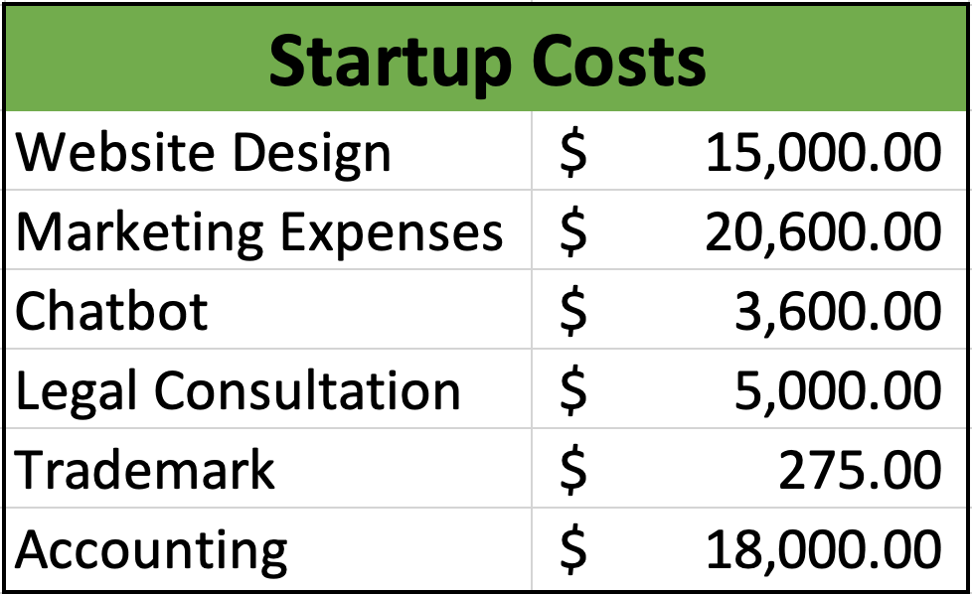
Growth and Exit Plan

Long-Term Goals

The Travelution team has developed a strategy for incremental growth over the next three years to substantially increase our value prior to an acquisition or merger with a larger travel business, or academic institution. We plan to be notorious for providing unfiltered college tours with candid, comprehensive information on campuses and their surrounding areas, led by current students at each university. This is intended to leave the prospective student with local knowledge that one does not receive from a rehearsed, monitored, administered campus tour. Incoming students and parents will be able to make educated decisions before committing to a school and taking on moving expenses.

The tasks and operations of Travelution will be solidified for proper implementation into new cities across the globe. As expansion takes place, we will aim for a minimum of 5% market share of all campus tours in each location to ensure profitability. However, we realistically believe that we can reach 10% market share. Along with tours, our other main revenue stream of itineraries will be projected to capture 3% market share. Annual revenue will vary based on the expansion into new cities each year, which we project to be operating in six major cities by year three. In total, within three years the company forecasts to reap $1.3 million in sales. Each location will bring in approximately $130,000 in revenue with our assumed 5% market share minimum for campus tours and 3% for itineraries.

Strategy for Achieving Goals

To reach our long-term goal of being the premier choice for a college campus tour, we will continue to expand into new cities for students to have the ability to tour any prospective college with us. Incremental growth will take place on an annual basis up until year three, which at that point we will evaluate our progress and consider expedited expansion. We believe in quality testing to ensure that every aspect of our company is ready for implementation into new schools. This ranges from the functionality and simplicity of our online platform, to our process for screening tour guides and hiring ambassadors.

The first priority is to begin pilot testing in Florida’s Tampa Bay area for year one. This location is advantageous as our founding team has a wide variety of connections throughout St. Petersburg, Tampa, and Clearwater. We are planning our beginning operations at the University of Tampa, where we are all current students. This will allow for quality control as we will easily be able to determine the effects of our services and monitor if modifications are needed. The second reason Tampa Bay is targeted as the
first trial city is the vast room for expansion to increase market share and brand recognition throughout year one. There are seven colleges (each with an undergraduate population of 1,000 or more) giving us a total undergraduate population of approximately 142,906 students in the area. Through primary research we have found that the amount of tours given at a university each year is approximately equal to the undergraduate population at that school. We will devote the first year in business to analyze, improve, and perfect operations in all areas necessary. The founding team will focus on guerilla and paid marketing efforts to increase brand awareness while reviewing feedback from all students and parents to make adjustments and provide the best service possible. We will take a hands-on approach and be involved in every aspect of Travelution before expanding and delegating responsibilities to others by growing our team.

In year two, our goal for effective customer and revenue growth is to expand into two cities with high undergraduate populations, as well as high tourism rates. By the end of year one our operations will be solidified, making it easier to take these processes and implement them into other schools. We strategically chose Miami and Chicago for year two growth, both cities having an undergraduate population of 130,338 and 213,758 respectively. Managers will be hired for all territories, and the founding team will serve as oversight for the entirety of our operations. Aggressive marketing and quality service will assist Travelution in successful and steady growth.

In year three we will expand into Washington DC, Boston, and Philadelphia with undergraduate populations of 172,994, 184,710 and 182,964 respectively. Our operations will remain as they were post beta testing, with receptiveness to needed adjustments for conducting business on a larger scale. At this point we will have a presence in six major cities, giving us the opportunity to provide services to approximately 145 universities. To expand our market share in every location beyond our minimum goal of 5%, focus will be placed heavily on guerilla and paid marketing efforts throughout the entirety.

Greater Expansion Plans

After our third year in business, Travelution will have an established reputation and a firm handle on the system for efficient expansion into new cities. At this point we will look to quickly spread across the United States, without sacrificing the quality of our services. This will require us to hire more managers and personnel to oversee territories and provide customer service for the tour guides as well as the prospective students. At this time the founding team will also be concentrating on marketing to graduating seniors and partnering with high schools and college fairs to make the process of visiting, choosing and applying for colleges streamlined and stress free. Another revenue stream we plan to incorporate is assistance with college applications. This will make Travelution a full-service college assistance program taking all customers from start to finish.

Throughout our first three years in business we will also be tracking data on how many student tours and itineraries resulted in students committing to a school. We will also monitor transfer rates to verify that Travelution clients are less likely to switch colleges due to our detailed tours. We will utilize this data as a catalyst for marketing to high schools.

After expansion efforts across the United States we will assess our progress and look into going global. Expanding into different countries will require more marketing towards itineraries and tours of the city as well as the campus, because realistically not as many people will travel to another country solely for a campus tour. Itineraries will be highly marketed encouraging people to get to know the area before committing to reside in that location for the next few years.

Risks Associated with Expansion

While our growth plan is well thought out and incremental, there are some barriers that we must account for. Not all campuses are “open,” meaning that proper student identification is required for entry. This would prohibit unauthorized people from trespassing, creating limitations for student administered campus tours that are not directly affiliated with the university. This factor could limit the quality of the tour, by allowing prospective students on campus, but preventing entry into vital aspects of the school such as the gym, classrooms, library and more. This could potentially be overcome by suggesting the student take the complimentary tour the college offers and converging with the student afterward to relay vital information that was not offered by the university. Another potential limitation is the direct competition with the universities who offer free tours to prospective students and parents. It is possible they may increase their marketing to affirm they offer thorough information.

The Exit Plan

Within 7-10 years we predict Travelution to be operating on a global scale with presence in hundreds of universities across the United States and Europe. We will have gained a following among college students and high school seniors. After establishing ourselves as a market leader for candid campus tours and itineraries, our prominence and success will allow opportunities for an exit strategy. Travelution will approach large travel companies such as TripAdvisor, to spark an acquisition or merger. Academic institutions will also be targeted. Chegg and Course Hero are other options popular among all students. They are known for revealing solutions and answers on homework and test questions which would fit right in line with our services.

Timeline

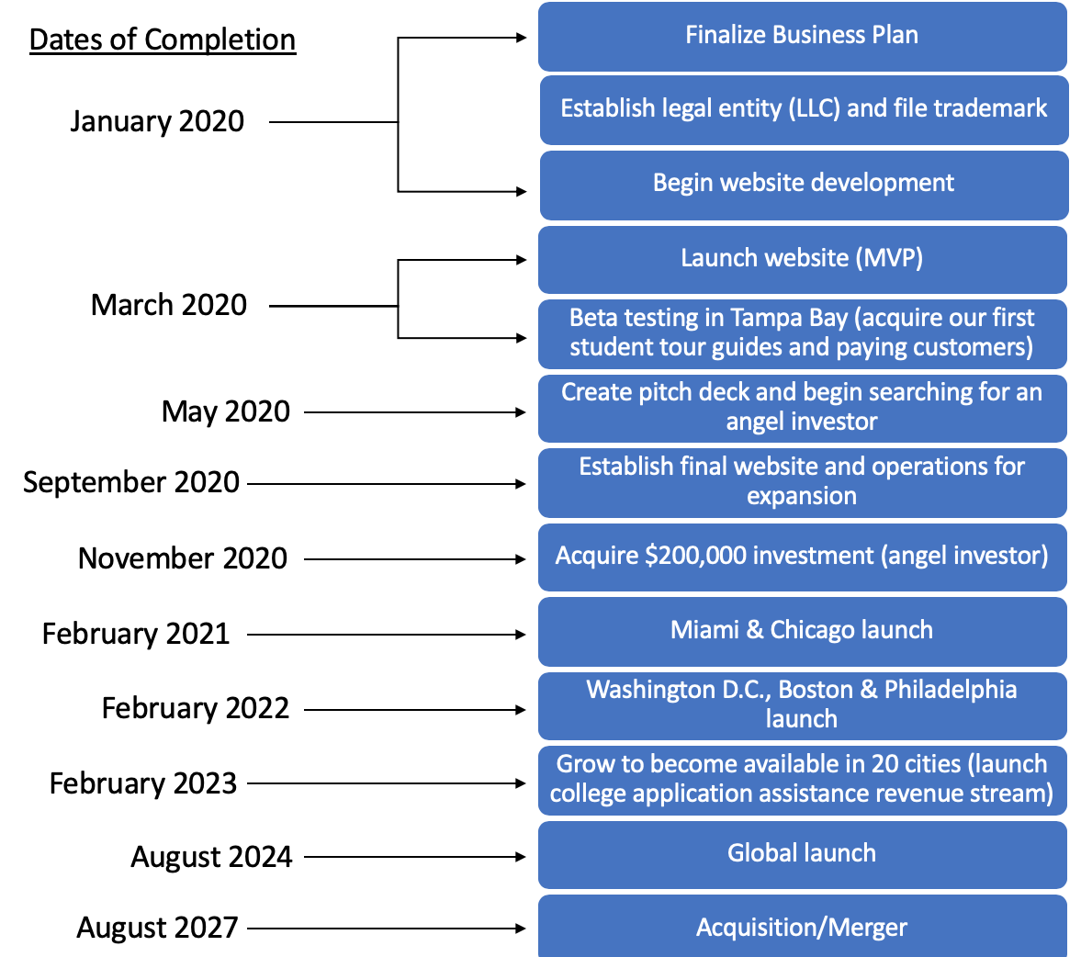

Financial Appendix

Revenue: Tours

The tour revenue was estimated based on the number of people to take a campus tour at the University of Tampa (UT) in a given year. After speaking with a few people at The University of Tampa admissions office, we learned there are between 8,000-10,000 tours at UT in a 12-month span, which is about the same as the current undergraduate enrollment (8,443). Based on this information, we assumed that each school will have around the same amount of people taking tours of their campus as their current undergraduate enrollment. We added up the undergraduate enrollment for the universities Tampa Bay for our year-one launch and found there are 142,906 undergraduate students. We then created three different models for this type of revenue: best case (10% of the population become users), most likely case (5% of the population becomes users), and worst-case (2% of the population becomes users). We took those numbers and divided them by 12 months (10 months for year one) and then multiplied those monthly numbers by an average price per tour $35 (assuming a one-hour tour and including our 35% upcharge fee). After some more research, we were able to assume that incoming college students are about three times more likely to take a campus tour during the semester than during a break. To sow the cyclical nature of our revenue, the expected number of tours for months 1, 5, 6, 7, 8 and 12 (the off-season) is multiplied by .5, and months 2,3,4, 9, 10 and 11 (the on-season) are multiplied by 1.5.

Revenue: Itinerary

The revenue from the sale of custom itineraries was estimated using the same method as tour revenue. Based on the undergraduate population in each city, we created three different revenue models: best case (5% of the population becomes users), likely case (3% of the population becomes users) and worst-case (1% of the population becomes users). Through our primary research, we found users would pay an average of $16 for a custom itinerary with the ambassador that provided it being paid $10.40 (assuming our 35% upcharge). We assume the revenue from itineraries will also be cyclical, so we chose to use the same formula used above for our expected tour revenue.

Revenue: Business Promotions

Our revenue from business promotions is based on promoting local businesses in a city on our website that fall into one of three categories: restaurants, indoor activities, and outdoor activities. We will select three businesses per category to offer an exclusive opportunity for each business. By expressing our desire to grow in each area and bring new people to the area, we are going to be requesting to start $50 per month for each business for year 1 ($50X9 business= $450 per month). We will come up with a coupon code with each business to have on our website to drive our customers to their businesses. After year one when we have established our brand and have data on the amount of traffic we are driving towards people, we will be requesting more money from the current businesses as well as the new business in new cities in year 2 and year 3. Year 2 we are adding 2 more cities and increasing the price to $75 per month. Year 3 we are adding 3 more cities and increasing the monthly price to $100.

Expense: Legal

We are going to be filing all legal paperwork (set up LLC, establish contracts, etc.) via an attorney named Sheryl Hunter for a price of about $5,000. We will also have the opportunity to work with attorneys for free via the incubator program at the University of Tampa.

Expense: Insurance

We will be purchasing general liability insurance as a membership or association policy for the ambassadors and locals. This insurance is priced at $1,600 each year but has been broken down as a monthly payment of $133.33.

Expense: Marketing

Our marketing expenses will consist of online advertisements, social media marketing, and merchandise to give to ambassadors and locals to represent our brand in their areas. We estimate that we will need about $10,000 to jump-start our marketing efforts in Tampa before we launch. After launch, we found that the industry standard for a marketing budget is about 8% of the company’s revenue. For year one we took 8% from the $200,000 investment we seek. For years two and three the marketing budget will be based on 8% of our yearly revenue.

Expense: Website Development

Ray has worked with a company called TEchAcs, Corp. in the past for website development. We have contacted them and were told the website we need would cost about $10,000 to develop.

Expense: Website Maintenance

The same company that builds our website (TEchAcs, Corp.) has told us they will remain on retainer for general website maintenance and SEO for $500 each month. This will help drive traffic to our website.

Expense: Accounting

Based off the industry average for a start-up company, we are estimating our accounting costs to be $1500 per month, pending on the accounting firm.

Expense: Employee Salaries

Through the use of IBIS world, we were able to find that the average salary for an employee in our industry is $45,600 annually. In year one our team plans to manage and operate Travelution without any outside employees. In years two and three, we expect to hire one employee each year at the average salary above to help with implementation and customer service. Factoring in benefits, the expense of taking on these two employees by year three can be seen on the following sheets.

Expense: Office Space

We will be using the incubator space at the University of Tampa for year one (no rent). Office space for years two and three will be located at 100 S. Ashley Drive via Easy Offices, which helps keep rent costs low for startups. With a growing team of six and seven years two and three, respectively, we will require office space from this location at a cost of about $2,000 each month.

Expense: Chatbot

We will be using a company to build an interactive chatbot that users can use to navigate the website and ask general questions about our company. The costs for this are to build and maintain the chatbot. Moreover, Travelution will also have a chatbot on their website to felicitate the customers needs. Travelotioun will sign a three year contract with DRIFT Pro plan which includes nine additional seats (so ten total). Normal pricing for the Pro plan is $400 per month, which comes with one human chat and an automated calendar seat, plus 9 additional seats at $40 per seat per month. Also, they offer online training session to learn how to personalize our chatbot for free,a total of $8400 per year. However, Startups with under $1 million in funding are eligible for a discount, which is 93% off in their first year, 50% in their second, and 25% in the third, a total of $6,888.

Appendix

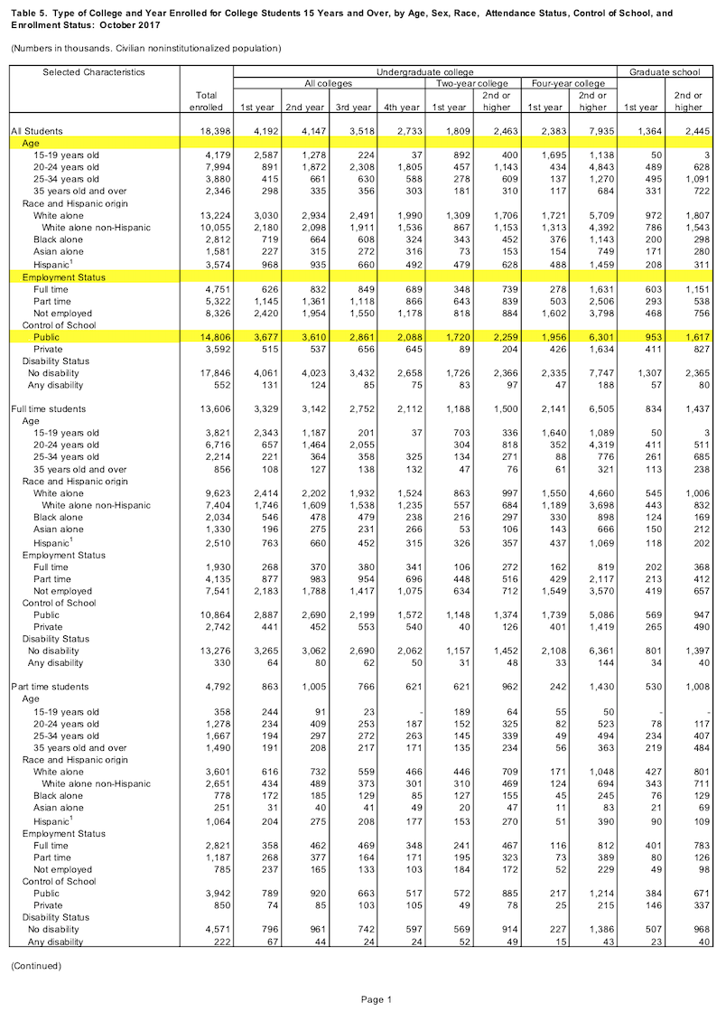
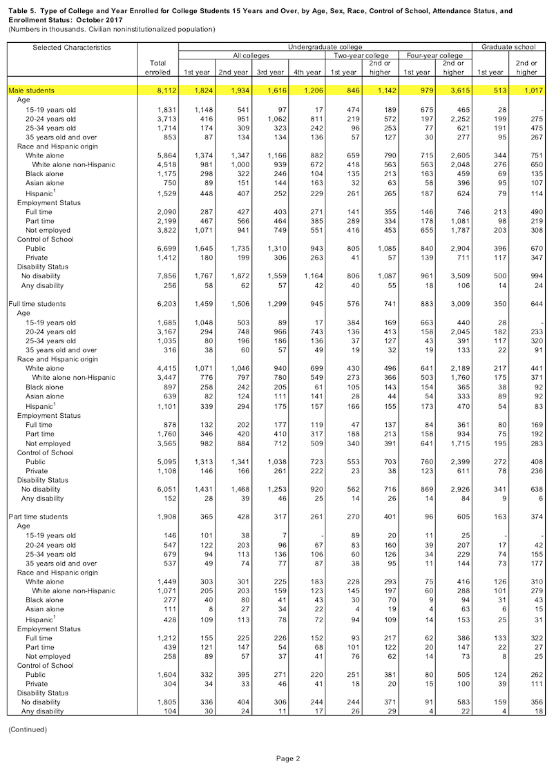
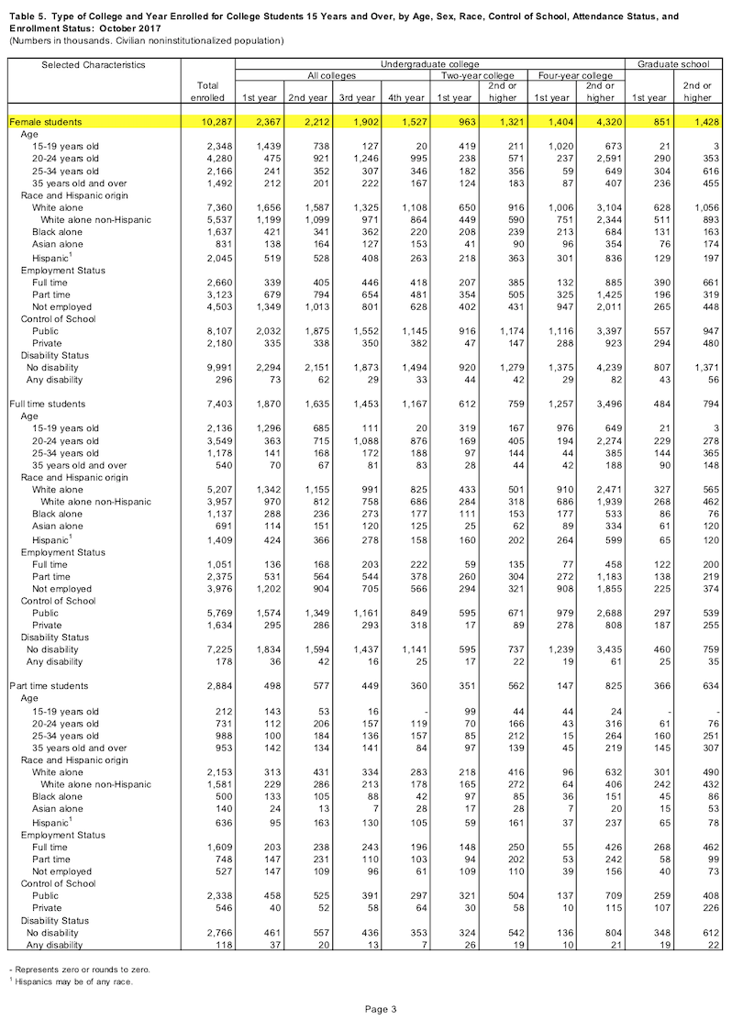
Survey Questions

1. When going abroad, how do you choose the location?

2. Do you enjoy trip planning? Why or why not?

3. Do you find trip planning easy, or challenging? Why?

4. What are some resources you use to plan a trip? (excluding flight booking)

5. Before visiting a new city, would you be interested in talking to a local there? Why or why not?

6. *for those who answered yes to #5* Would you prefer to talk to a local before a long trip (a week or longer), or a short one (a weekend)?

7. *those who answered no to #5 skip to #7* Gender?

8. Race?

9. Age?

10.Which country are you from? State?

Focus Group Questions
Name: ____________________
Year: _____________________
Where You Are From: ____________________
- How many different states in America have you been to?
- How many different countries have you been to?
- Do you enjoy traveling to places you have never been?
- Tell us about how you travel to new destinations: solo, with one other, or in a group.
- Did you take a tour when visiting the University of Tampa? If so, was it helpful?
- Do you feel like you are able to relate more to people your age, older than you, or younger than you? Why?
- What type of research do you do on a place before you visit it? Is it brief or extensive?
- How do you feel about this concept of Travelution?
- Would you be an ambassador? If not, do you think your friends would?
- What do you recommend we do to improve Travelution?
- Would you use Travelution? If yes, how would you use it? If not, why not?
- Would you use Travelution when traveling solo, with one other, in a group or all situations?
- What are your main concerns when embarking on travel to a new country?
- What is your willingness to pay for the tours? Itinerary? What would you charge for tours? Itinerary?
International Focus Group Results

- 3 males and 1 female
- 2 from Saudi Arabia, 2 from Spain
- Want to travel more within states and to different countries
- Feel like they learn more about different cultures from going to a place rather than reading about it
- People travel alone to big tourist destinations to meet other people and to do what they want to do
- Tours at University of Tampa (UT) they felt were not helpful; Member of the focus group is a tour guide for UT and said that they are discouraged from talking about the cons of UT
- Felt like they related to people their age or older, not younger
- They use hotel receptionists and talk to people while they are there in terms of figuring out what to do
- They like the local feel of Travelution
- They all would be an ambassador
- Recommended to have a phone number through Travelution website/app like uber where you can safely connect with an ambassador without giving out your personal information
- Recommended to have ambassadors with cars list that and have their prices be a little high for gas money
- They all would use Travelution
- They felt like they would use the itinerary more if they took a tour with the person first
- They all would use Travelution when traveling alone, but only ¾ would while in a group because they felt like if they are traveling with friends they don’t want structure
- All of their main concerns were safety of toru ambassadors
- Willingness to pay for tours: $15-20, $25, $30
- List price for them to give a tour: $25, $30, $30
- WIllingness to pay for itinerary: $5, $15
- List price for them to give out itinerary: $10,$15
- One person said it all depends on supply and demand of the services
- One said they would like a flat fee

American Focus Group Results

- 5 males and 4 females
- Want to travel more within states and to different countries
- Feel like they learn more about different cultures from going to a place rather than reading about it
- Mix of group and solo travel
- 7/9 took a tour at UT while visiting and said it was hard to remember everything all at once; felt like UT was trying to sell them on the school and only showed them all the best places to see
- 8/9 people relate more to people their own age; 1 said older; No one for younger due to maturity
- They look at places to stay and where to travel in an area before visiting it
- 7/9 would use Travelution; 2 who said no was because they don’t like to have a set schedule while traveling, as well as they safety aspect
- 7/9 would be an ambassador; 2 who wouldn’t was because of the commitment
- Recommended the phone service like the international group did
- Recommended having an option for the ambassadors “rent” out their house like Air BnB; would be more comfortable staying with an approved ambassador rather than random people
- 3/9 would use it while traveling solo; felt if they did it solo then they wouldn’t want the tour guide to know they are alone
- 9/9 would do it in a group, but felt like if they were with their family that the family might not want to
- Concerns: 9/9 said safety, money ratio differences in terms of the prices, language barrier, having someone know you are traveling alone
- Willingness to pay for tours: $50, $10 per hour, $100, $500-1000, $11 per hour, $100-200, $50 for 3 hours, $15-20 per hour, $15-20 per hour,
- List price for them to give a tour: $50, $10 per hour, $75, $500-1000, $15 per hour, $150-200, $50-60 for 3 hours, $20-30 per hour, $15-20 per hour
- WIllingness to pay for itinerary: $20, $50, $3 per place/item,
- List price for them to give out itinerary: $20,$50, $5 per place/item,
- Willingness to pay for staying at the ambassador's house: $100 per night

References
Airbnb Business Model. (2019). Retrieved from https://bmtoolbox.net/stories/airbnb/.

Angel Funding, Fundraising. (n.d.). What are the expected legal costs for a startup at the angel and Series A stages? Retrieved October 29, 2019, from Law Trades:
Bellin, John ZealleyRobert WollanJoshua. “Marketers Need to Stop Focusing on Loyalty and Start Thinking About Relevance.” Harvard Business Review, 5 Dec. 2018, hbr.org/2018/03/marketers-need-to-stop-focusing-on-loyalty-and-start-thinking-about-relevance.
Bort, J. (2018, February 6). Airbnb made $93 million in profit on $2.6 billion in revenue, but an internal clash sent the CFO out the door. Retrieved from https://www.businessinsider.com/airbnb-profit-revenue-2018-2.

DINESH, D., WRITER, C., & MEDIA, G. (2017). Why Micro-Influencers Are a Social Media Marketing Imperative for 2017. EContent, 40(3), 14–15. Retrieved from http://search.ebscohost.com.esearch.ut.edu/login.aspx?direct=true&db=a9h&AN=122805273&site=ehost-live

Doherty, A. (2019). Join the Micro Wave. Travel Trade Gazette UK & Ireland, (3241), 36–37. Retrieved from http://search.ebscohost.com.esearch.ut.edu/login.aspx?direct=true&db=bth&AN=136545893&site=ehost-live
Ercule, Team. “Marketing to College Students – SheerID Learning.” SheerID, 11 Oct. 2019, www.sheerid.com/marketing-to-college-students/.
(Everett Potter. (2017). 5 myths about Millennial travelers. USA Today. Retrieved from http://search.ebscohost.com.esearch.ut.edu/login.aspx?direct=true&db=a9h&AN=J0E267979253017&site=ehost-live).

Editors, Reader's Digest. “How to Adjust to a New City You May Not Love.” Reader's Digest, Reader's Digest, 26 July 2019, https://www.rd.com/advice/travel/how-to-adjust-to-a-new-city-you-may-not-love/.

GetYourGuide Competitors, Revenue and Employees - Owler Company Profile. (2019.). Retrieved from https://www.owler.com/company/getyourguide.

Hamill, V. (2019, June 10). LLC: How much you need & what it should cost? Retrieved October 29, 2019, from Fit Small Business: https://fitsmallbusiness.com/llc-insurance/

Holcomb, G. (2019). Tour operators in the US. IBIS World Industry Report 56152. 1-14.
IBISWorld, Inc. “Industry Market Research, Reports, and Statistics.” IBISWorld, clients1.ibisworld.com/reports/us/industry/keystatistics.aspx?entid=1482.
Liberty Travel Competitors, Revenue and Employees - Owler Company Profile. (2019). Retrieved from https://www.owler.com/company/libertytravel.
McCubbin, James. “Student Demographics in Higher Education.” Student Demographics in Higher Education, 12 Oct. 2018, blog.campus.app/student-demographics-in-higher-education.
Mildenhall, by Jonathan Mildenhall. “How Airbnb Built Its Brand by Telling the World Not to Travel.” PR Week, Airbnb, 18 Sept. 2017, https://www.prweek.com/article/1444913/airbnb-built-its-brand-telling-world-not-travel.
Rivas, Julia, et al. “Seeking a Sense of Belonging: Social and Cultural Integration of International Students with American College Students.” Journal of International Students, vol. 9, no. 2, 25 Jan. 2018, pp. 687–703.
Southan, J. (2019, September 28). Where women no longer fear to tread - Travel companies are responding to the sharp rise in demand for female solo journeys, writes Jenny Southan. Daily Telegraph, The (London, England), p. 10. Available from NewsBank: Access
World News: https://infoweb-newsbank-com.esearch.ut.edu/apps/news/document-view?p=AWNB&docref=news/1763D27068ADA688

TripAdvisor Revenue 2010-2019: TRIP. (2019, October 3). Retrieved from https://www.macrotrends.net/stocks/charts/TRIP/tripadvisor/revenue.

ToursByLocals Competitors, Revenue and Employees - Owler Company Profile. (2019). Retrieved from https://www.owler.com/company/toursbylocals.
“US Disposable Personal Income Per Capita:” YCharts, Oct. 2019, ycharts.com/indicators/us_disposable_personal_income_per_capita.
Withlocals Competitors, Revenue and Employees - Owler Company Profile. (2019). Retrieved from https://www.owler.com/company/withlocals.

Xiang, Z., & Fesenmaier, D. R. (2017). Big data analytics, tourism design and smart tourism. In Analytics in smart tourism design (pp. 299-307). Springer, Cham.

https://3rxg9qea18zhtl6s2u8jammft-wpengine.netdna-ssl.com/wp-content/uploads/2017/09/FINAL_American_Multi-Gen_Travel_Trends_Gen-Visuals.pdf

